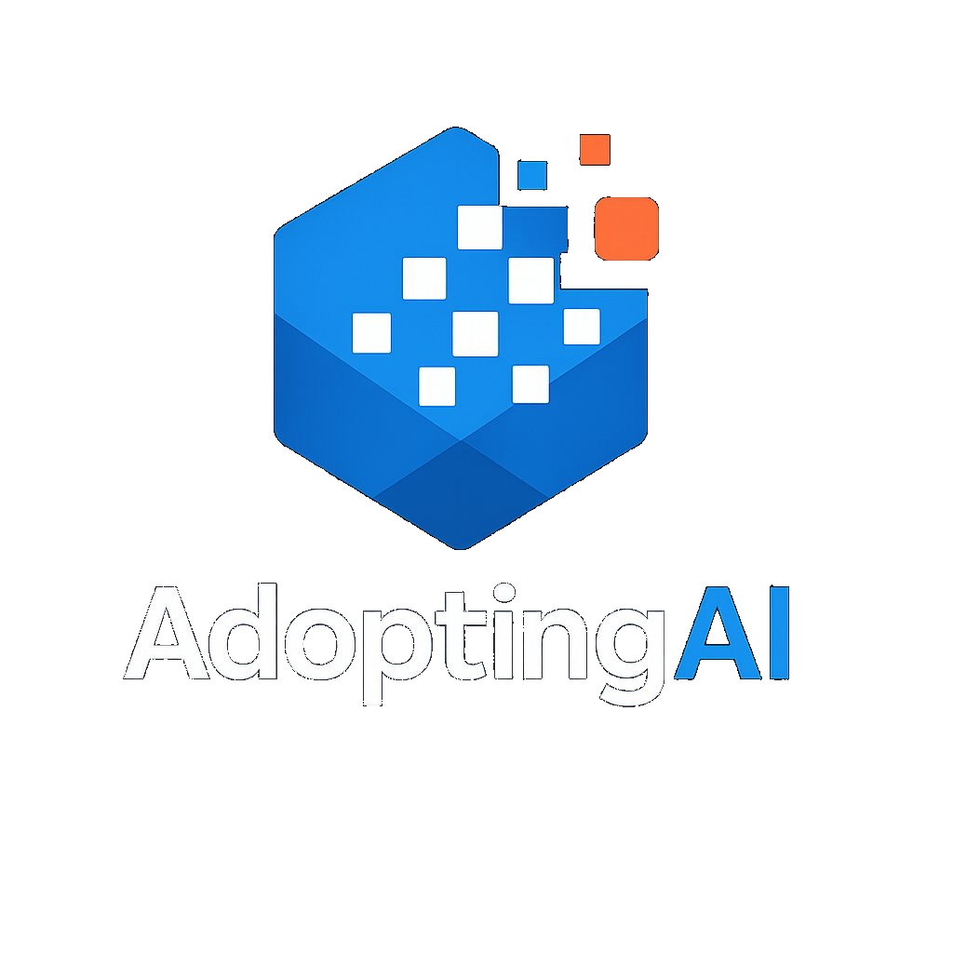 | ARIA  AI Readiness and Integration Advisory Framework  Full Methodology Reference | AdoptingAI

The Challenge
Most organizations struggle to identify where AI can genuinely transform their operations, not because AI capability is lacking, but because the opportunity is invisible from the inside. Business teams know their processes deeply but rarely have the frame of reference to see where AI could eliminate days of manual work, remove entire categories of decision bottlenecks, or replace months-long cycles with near-instant outputs. Teaching people what AI is and making technology options available does not solve this. Without a structured method for examining how work actually gets done, most organizations default to incremental thinking and miss the transformational opportunities entirely.

What is ARIA
ARIA is the AdoptingAI AI Readiness and Integration Advisory Framework. It is a structured engagement methodology that uses AI-powered research and specialized advisory expertise to surface where AI can create transformational operational value. ARIA produces a prioritized, evidence-based AI Strategy Roadmap: a detailed, client-specific proposal covering high-impact use cases, a readiness assessment, and a sequenced implementation plan grounded in the client's actual environment.
The output identifies what AI-enabled transformation is achievable and what preparation is required to get there. How that transformation is executed, whether through internal teams, third-party vendors, or a combination, is determined by the client based on the findings.
ARIA replaces weeks of manual research and shallow discovery with a structured, AI-accelerated process. The ARIA Research Tool conducts deep preparatory research automatically before any client meeting takes place. Every client interaction is structured around four operational lenses that surface AI opportunities the client may not have thought to ask for. Every output is produced through a combination of ARIA tooling and advisor expertise, making the engagement faster, deeper, and more defensible than traditional approaches.

The ARIA Process
ARIA moves through five stages, alternating between advisor-led analysis and structured client meetings. The visual below shows the full process at a glance.

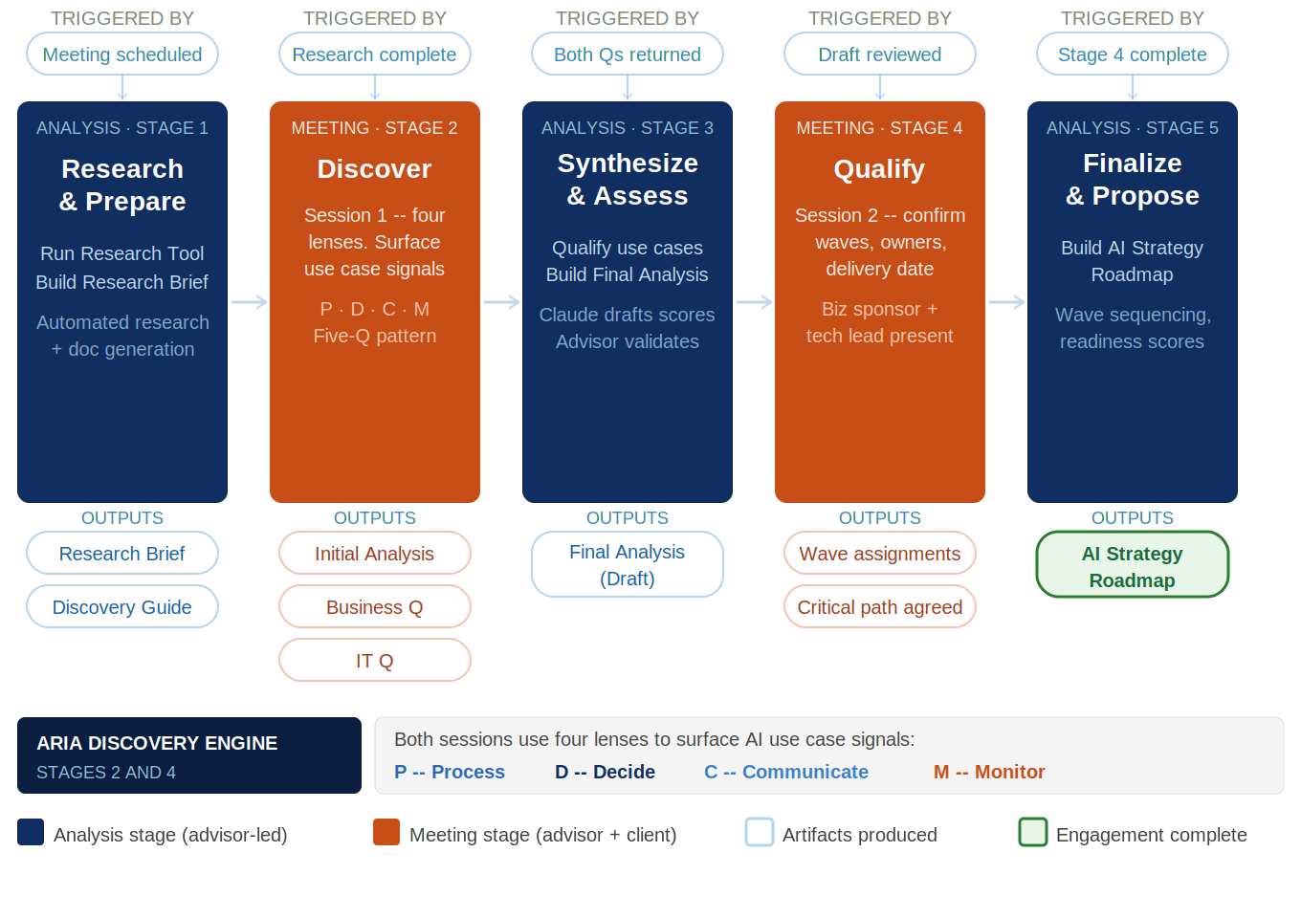

How ARIA Works
ARIA alternates between advisor-led analysis stages and structured client meetings. Analysis stages are where research is conducted, discovery is synthesized, and the final roadmap is produced. Meeting stages are where the advisor works directly with the client to surface opportunities and validate findings. Every client interaction is informed by deep preparation, and every piece of analysis is grounded in what the client actually said, not what research alone suggested.
Because the analysis stages are powered by ARIA AI tooling rather than manual research, the full engagement can move at a pace that traditional approaches cannot match. Both client meetings and all analysis between them can be completed within consecutive days. An engagement that would take weeks with conventional research and discovery can be delivered in a fraction of the time without sacrificing depth or defensibility.
Discovery is organized around four operational lenses: Process, Decide, Communicate, and Monitor. These lenses are defined in detail later in this document. Together they ensure that AI opportunities are surfaced systematically across the full operational landscape, including areas the client would not have identified through traditional intake or requirements processes.

Stage Summary

# | Type | Stage | Input | Output
1 | Analysis | Research and Prepare | Initial client meeting scheduled | ARIA Research Brief, ARIA Discovery Guide
2 | Meeting | Discover | ARIA Discovery Guide completed, session transcript available | ARIA Initial Discovery Analysis, Business Readiness Questionnaire, IT Readiness Questionnaire
3 | Analysis | Synthesize and Assess | Both questionnaires returned by client | ARIA Final Discovery Analysis (Draft)
4 | Meeting | Qualify | ARIA Final Discovery Analysis (Draft) reviewed by client | Qualified use case candidates, Validated readiness inputs
5 | Analysis | Finalize and Propose | All discovery inputs gathered | AI Strategy Roadmap

Stage Detail
Each stage is described below with entry and exit conditions, advisor and client responsibilities, and artifacts produced.

1 | ANALYSIS | Research and Prepare

The ARIA Research Tool conducts structured, AI-powered research on the client before any meeting takes place. It surfaces company context, technology environment, strategic signals, and initial use case candidates based on publicly available information. The AdoptingAI advisor reviews and validates the output, applying domain expertise before the first meeting. What would take days of manual research is completed automatically, giving the advisor a strong, informed foundation rather than starting from scratch.

Entry Conditions  - Initial client meeting has been scheduled  - Engagement scope confirmed at a high level | Exit Conditions  - ARIA Research Brief complete and advisor-validated  - ARIA Discovery Guide pre-populated and ready for advisor review  - Advisor has reviewed both documents and is prepared for the discovery meeting

Advisor Responsibilities  - Run the ARIA Research Tool against the client organization  - Review and validate AI-generated research output  - Apply domain expertise to refine initial use case candidates  - Review the pre-populated ARIA Discovery Guide and confirm anchor questions are appropriate for this client | Client Responsibilities  N/A

Artifacts Produced
- ARIA Research Brief -- AI-generated and advisor-validated. Covers company background, technology environment, regulatory context, and strategic signals. Internal use only.
- Initial Discovery Analysis (Draft) -- pre-populated by ARIA tooling from the research output. Provides a structured framework and research-informed use case starting points for the first meeting.

2 | MEETING | Discover

The first structured client meeting. The advisor uses the Initial Discovery Analysis (Draft) as a starting framework, not a script. The four operational lenses guide the conversation across the client's actual operational landscape. Initial use case candidates from Stage 1 provide a starting point based on publicly available research and will be refined significantly through genuine discovery. The advisor listens for signals the client may not frame as AI opportunities and captures responses in real time. The output is a completed Initial Discovery Analysis and a preliminary set of real candidate use cases grounded in the client's actual context.

Entry Conditions  - ARIA Research Brief complete  - ARIA Discovery Guide pre-populated and advisor-reviewed  - Client meeting confirmed with appropriate attendees | Exit Conditions  - ARIA Discovery Guide completed with session notes across all four lenses  - Preliminary use case candidates identified  - Key readiness signals captured  - Gaps and open questions for Stage 4 identified

Advisor Responsibilities  - Lead the discovery conversation using the Initial Discovery Analysis as a guide  - Apply all four operational lenses across the client's operational landscape  - Capture client responses in real time  - Surface AI use case signals the client may not be framing as AI opportunities  - Note key gaps that Stage 4 will need to address | Client Responsibilities  - Attend with relevant operational and technology stakeholders  - Engage openly with discovery questions  - Flag areas of prior initiative history, organizational sensitivity, or known constraints

Artifacts Produced
- Initial Discovery Analysis -- completed live during the meeting. Captures actual client responses and confirmed use case signals across the four operational lenses. Primary input to Stage 3.

3 | ANALYSIS | Synthesize and Assess

The advisor synthesizes the Stage 2 discovery and assesses what readiness activities would be required to enable each candidate use case. The Client Readiness Questionnaire is AI-generated at this stage using the Stage 2 discovery output as its input, producing questions tailored specifically to the use case candidates and operational context that emerged from the first meeting. This is not a generic questionnaire. It reflects what this engagement has learned. It includes a Value sizing section in which the client provides a High, Medium, or Low estimate of the business value each use case candidate represents, anchored by criteria covering process volume affected, cost or time of the current manual process, and strategic priority of the outcome. It is sent to the client for completion before Stage 4. The Final Discovery Analysis (Draft) is also built at this stage to frame the second meeting.

Entry Conditions  - Initial Discovery Analysis completed  - Advisor has reviewed discovery notes and identified priority patterns | Exit Conditions  - Client Readiness Questionnaire AI-generated, advisor-reviewed, and issued to client  - Final Discovery Analysis (Draft) built and sent to client ahead of Stage 4  - Preliminary use case shortlist established

Advisor Responsibilities  - Review the Initial Discovery Analysis and identify use case patterns across the four lenses  - Develop a preliminary shortlist of candidate use cases  - Run ARIA tooling to generate the Client Readiness Questionnaire from Stage 2 outputs  - Review and validate the AI-generated questionnaire before issuing to the client  - Build the Final Discovery Analysis (Draft) framed around qualifying the shortlist | Client Responsibilities  N/A

Artifacts Produced
- Client Readiness Questionnaire -- AI-generated from Stage 2 discovery outputs, with questions tailored to the specific candidates and operational context that emerged from the first meeting. Includes a Value sizing section in which the client rates each use case candidate High, Medium, or Low based on anticipated business value, with anchoring criteria provided. Advisor-reviewed before issue. Sent to the client for completion before Stage 4.
- Final Discovery Analysis (Draft) -- frames the Stage 4 meeting around qualifying the candidate use cases. Sent to the client ahead of Stage 4.

4 | MEETING | Qualify

The second structured client meeting. With the readiness questionnaire completed and the Final Discovery Analysis in hand, the advisor and client work through each candidate use case to assess which are achievable given the client's actual environment. This session produces the validated, qualified use case set that the AI Strategy Roadmap will be built around.

Entry Conditions  - Client Readiness Questionnaire completed and returned  - Final Discovery Analysis (Draft) reviewed by client  - Preliminary use case shortlist established in Stage 3 | Exit Conditions  - Use case candidates qualified and validated  - Readiness inputs confirmed with the client  - All inputs needed for Stage 5 gathered

Advisor Responsibilities  - Lead the qualification conversation using the Final Discovery Analysis  - Work through each use case candidate against qualification criteria  - Validate readiness questionnaire responses and probe gaps  - Confirm the qualified use case set that the AI Strategy Roadmap will be built around | Client Responsibilities  - Attend with relevant stakeholders  - Engage honestly with use case qualification criteria  - Clarify or expand on readiness questionnaire responses as needed

Artifacts Produced
- Qualified use case candidates -- validated and confirmed through the Stage 4 session, with qualification rationale captured
- Validated readiness inputs -- confirmed readiness questionnaire responses, used for scoring in Stage 5

5 | ANALYSIS | Finalize and Propose

The advisor synthesizes all discovery and qualification inputs into the AI Strategy Roadmap. Readiness scores are applied across the four pillars. Use cases are prioritized and sequenced using three weighted dimensions: technical readiness, business urgency, and relative ROI. ROI is expressed as two inputs per use case: a Value size (High, Medium, or Low) provided by the client in the Stage 3 questionnaire, and an Investment size (High, Medium, or Low) derived by the advisor from the technical readiness findings, data infrastructure gaps, integration complexity, and implementation dependencies gathered across the engagement. High Value and Low Investment use cases are lead prioritization candidates. No single dimension wins automatically, but all dimensions are visible in the roadmap with sequencing rationale per use case. Preparation workstreams are identified and organized by readiness pillar. The roadmap is produced through ARIA AI tooling and advisor expertise and delivered as a detailed, evidence-based proposal the client can act on immediately.

Entry Conditions  - ARIA Final Discovery Analysis validated and updated post Stage 4  Stage 4 session notes captured with confirmed wave assignments, critical path items, and named owners | Exit Conditions  - AI Strategy Roadmap complete and ready for client delivery  - ARIA engagement concluded

Advisor Responsibilities  - Score the readiness questionnaire responses across the four pillars  - Apply the use case prioritization methodology to the qualified candidates, incorporating Value sizing (client-provided H/M/L from Stage 3) and Investment sizing (advisor-derived H/M/L based on technical readiness findings, data gaps, and implementation complexity)  - Develop sequencing rationale: quick wins, strategic bets, longer-term investments  - Identify preparation workstreams by readiness pillar  - Produce the AI Strategy Roadmap through ARIA tooling and advisor synthesis | Client Responsibilities  N/A

Artifacts Produced
- AI Strategy Roadmap -- five-section synthesis covering: (1) client context and strategic environment, (2) readiness assessment results by pillar, (3) prioritized use cases with sequencing rationale showing Value (client-provided H/M/L), Investment (advisor-derived H/M/L), and technical readiness per use case, (4) preparation workstreams, (5) recommended next steps. Produced through ARIA AI tooling and advisor expertise.

Client Readiness Questionnaire
The Client Readiness Questionnaire is AI-generated in Stage 3 using the Stage 2 discovery output as its source. Questions are tailored to the specific use case candidates and operational context identified in the first meeting. The questionnaire is organized around four readiness pillars, each covering distinct categories of organizational capability. The responses feed directly into readiness scoring in Stage 5. The scope and coverage of each pillar is described below.

Pillar 1: Data Readiness
Data readiness is the most common blocker and the most frequently misunderstood pillar. It probes two sub-categories.
Data Availability and Quality
This sub-category establishes what core data assets exist, in what form, and whether they are accessible for AI use. It examines the availability and structure of key data domains relevant to the candidate use cases. It assesses longitudinal data depth, whether a master data management function exists and is enforced, and how data quality is measured and remediated. The goal is to distinguish between organizations that describe their data as good and those that can demonstrate it.
Integration and Interoperability
This sub-category examines how data flows across systems and whether the integration architecture can support AI workloads. It covers API implementation status for relevant data domains, the maturity of the core operational platform, and whether real-time data access exists or all access is batch-only. It also examines the proportion of inputs arriving in unstructured formats such as fax or scanned documents, which directly affects the dependency on AI-based extraction and the quality achievable for use cases that rely on that data.

Pillar 2: Technology Readiness
Technology readiness examines whether the infrastructure required to deploy and operate AI exists or can be assembled without significant foundational work first.
Cloud and AI Infrastructure
This sub-category covers the cloud platform in use and whether data processing agreements are in place specifically for AI and machine learning workloads. It assesses whether existing model deployment infrastructure is available or whether that capability would need to be built. Agreement coverage for AI workloads is a frequent gap in organizations whose cloud contracts predate their AI ambitions, and it surfaces consistently as a late-stage implementation risk when not identified early.
Platform and Integration Architecture
This sub-category examines the API surface of the core operational platform, the availability and capacity of an integration team, and whether a sandbox or development environment exists for AI pilot work. Integration architecture is consistently the longest and most expensive phase of AI implementation. Its maturity is a primary input to use case sequencing and risk assessment in Stage 5.

Pillar 3: People and Process
People and process readiness determines whether the organization has the leadership, capacity, and operating model to implement and sustain AI.
Organizational Readiness
This sub-category assesses executive sponsorship for AI initiatives, whether a named AI lead or equivalent role exists, and the depth of internal capability to support implementation. It also probes the history of prior AI or automation pilots, including what was attempted, what succeeded, what failed, and why. Prior pilot failures are high-value signals. They often reveal organizational blockers that are more significant than any technology gap.
Operating Model and Change Management
This sub-category examines how decisions about AI adoption currently get made and whether a governance body with clear decision rights exists. It assesses change management capacity, specifically whether the organization has successfully navigated large-scale operational change in recent years. It also probes AI literacy across business, operational, and technology stakeholders. The gap between leadership enthusiasm and front-line readiness is a consistent implementation risk and one that sequencing and preparation workstreams must account for.

Pillar 4: Governance and Risk
Governance and risk is a lens applied throughout the engagement. The questionnaire formalizes the structured assessment before findings are finalized.
Regulatory Exposure by Use Case
This sub-category examines the regulatory obligations relevant to the client's specific qualified use cases. Regulatory exposure is use-case-dependent and is assessed against the actual qualified use case list developed through Stages 2 and 4, not against generic categories. Questions cover applicable compliance requirements, audit trail obligations, and any sector-specific AI governance mandates that apply to the use cases under consideration.
Data Handling and Privacy Policy
This sub-category establishes where data can be stored and processed, including any residency requirements and data sovereignty obligations. It examines whether the organization has a clear policy distinguishing between vendor certification and the specific data processing coverage required for AI workloads. Assumptions in this area are a frequent source of late-stage project risk and are surfaced here to avoid discovery during implementation.
Vendor and Contractual Governance
This sub-category covers the governance structures that apply to AI vendor relationships. It examines audit trail and explainability requirements, specifically whether individual decision-level traceability is required for the use cases under consideration. It covers third-party assessment expectations, data return and portability provisions, and for earlier-stage vendors, acquisition provisions and transition assistance obligations. These considerations are inputs to both use case sequencing and preparation workstreams in the AI Strategy Roadmap.

ARIA Artifacts Reference
Every ARIA engagement produces six standard artifacts. Each is produced through a combination of ARIA AI tooling and advisor expertise, with AI handling research generation and document assembly and the advisor providing validation, interpretation, and strategic judgment.

ARIA Research Brief Stage 1 | Internal
AI-generated by the ARIA Research Tool and validated by the AdoptingAI advisor before use. Covers company background, known contacts, technology environment signals, and strategic positioning. Informs the discovery approach and feeds the Initial Discovery Analysis (Draft). Not shared with the client.

Initial Discovery Analysis (Draft) Stage 1 | Internal
Pre-populated by ARIA tooling from the research output. Provides a structured discovery framework and research-informed use case starting points for the first client meeting. Reviewed and validated by the advisor before use. Represents the best available hypothesis before genuine discovery begins.

Initial Discovery Analysis Stage 2 | Internal / Working
Completed live during the first client meeting. Captures actual client responses organized across the four operational lenses. Replaces the research-informed hypotheses with what the client actually described. Primary input to Stage 3 synthesis and the foundation for all subsequent analysis.

Client Readiness Questionnaire Stage 3 | Client-facing
AI-generated from the Stage 2 discovery output, with questions tailored to the specific use case candidates and operational context that emerged from the first meeting. Includes a Value sizing section in which the client rates each use case candidate High, Medium, or Low based on anticipated business value, with anchoring criteria provided. Advisor-reviewed before issue. Sent to the client asynchronously for completion before Stage 4. Not a generic template. Inputs feed directly into readiness scoring in Stage 5.

Final Discovery Analysis (Draft) Stage 3 | Client-facing
Built by the advisor from Stage 2 synthesis. Frames the Stage 4 meeting around qualifying the candidate use cases identified in discovery. Signals to the client that the advisor has synthesized the first conversation and arrived with a structured point of view for the second.

AI Strategy Roadmap Stage 5 | Client deliverable
The final ARIA output. Five sections: (1) client context and strategic environment, (2) readiness assessment results by pillar with scores and narrative, (3) prioritized use case recommendations with sequencing rationale showing Value (client-provided H/M/L), Investment (advisor-derived H/M/L), and technical readiness per use case, (4) preparation workstreams organized by readiness pillar, (5) recommended next steps. Produced through ARIA AI tooling and advisor expertise. Enables the client to drive AI adoption on their terms.

Four Operational Lenses
The four operational lenses structure every ARIA discovery conversation. They ensure that AI opportunities are explored systematically across the full operational landscape, including areas the client would not typically identify through traditional intake processes. Each lens is applied with human judgment throughout, and human oversight is incorporated where the nature of the decisions, communications, or outputs requires it.

P | Process | Examines how work gets done and where AI can enable intelligent, semantic workflow automation that goes beyond traditional rule-based approaches to handle complexity, variation, and judgment within operational tasks.  Intelligent document handling, semantic data extraction, adaptive workflow routing, and throughput improvement. Examples: intake processing, document generation, extraction from unstructured sources.
D | Decide | Examines where judgments or determinations are being made and where AI, with human oversight where appropriate, can improve the quality, consistency, and speed of those decisions.  Decision support, criteria application, scoring, and anomaly detection. Examples: clinical criteria application, risk stratification, claims anomaly flagging.
C | Communicate | Examines how information flows to and from stakeholders and where AI can improve the quality, speed, or personalization of those interactions, with human review applied where the stakes require it.  Response generation, content personalization, summarization, and AI-assisted messaging. Examples: member-facing chatbots, provider communications, internal briefings.
M | Monitor | Examines what the organization needs to track on an ongoing basis and where AI can surface signals, anomalies, or performance gaps that would otherwise require manual surveillance.  Surveillance, performance tracking, anomaly detection, and operational dashboards. Examples: quality measure gap monitoring, network adequacy, fraud pattern detection.

1. Open ARIA_Stage4_Prompt.txt and fill in the variables
2. Paste the updated ARIA Final Discovery Analysis (post Stage 4) into Input 1
3. Paste your Stage 4 session notes into Input 2 -- these take priority where they conflict with Input 1
4. Paste final readiness scores into Input 3
5. Paste the complete prompt into a new conversation in the ARIA Engagement Project
6. Claude produces the AI Strategy Roadmap -- review all five sections before delivering
7. Send the roadmap on the agreed delivery date with a two-paragraph cover note

No HTML tool yet -- use the prompt template directly
STAGE 5 -- FINALIZE AND PROPOSE

1. Walk through each use case in the ARIA Final Discovery Analysis (Draft)
2. Confirm wave assignments with the client
3. Agree critical path items with named owners and specific timelines
4. Confirm the AI Strategy Roadmap delivery date -- name a specific date, not a range
5. Capture all agreed decisions in session notes

No tool -- run the session from the Stage 3 document
STAGE 4 -- QUALIFY

1. Wait until both questionnaires have been returned. Do not start Stage 3 before both are back.
2. Open ARIA_Stage3_Prompt.txt and fill in the variables at the top
3. Paste the ARIA Initial Discovery Analysis text into Input 1
4. Paste the completed IT Questionnaire responses into Input 2
5. Paste the completed Business Questionnaire responses into Input 3
6. Paste the complete prompt into a new conversation in the ARIA Engagement Project
7. Claude applies the use case qualification gates, runs the completeness check, and drafts readiness scores
8. Claude produces the ARIA Final Discovery Analysis (Draft)
9. Validate the qualification decisions and readiness scores using the spreadsheet tools
10. Refine the document as needed, then send to the client at least 48 hours before Stage 4

No HTML tool yet -- use the prompt template directly
STAGE 3 -- SYNTHESIZE AND ASSESS

1. Run the discovery meeting using the ARIA Discovery Guide. Take rough notes in the capture fields during the session.
2. After the session, read the transcript and fill in the Discovery Guide capture fields more completely.
3. Open ARIA_Stage2_Tool_v2.html in your browser
4. Fill in session details: Client Name, Session Date, Focus Areas, Participants, Session Format
5. Upload the completed ARIA Discovery Guide (.docx) -- wait for the parse confirmation message before proceeding
6. Upload the session transcript (.txt or .docx) -- recommended, improves output quality
7. Add any additional advisor notes in the text field
8. Click Build Stage 2 Prompt -- review the content preview to confirm both files parsed correctly
9. Click Copy Prompt and paste into a new conversation in the ARIA Engagement Project
10. Claude produces three documents: ARIA Initial Discovery Analysis, Business Readiness Questionnaire, IT Readiness Questionnaire
11. Review all three documents, then send both questionnaires to the client within 24 hours
12. State the five business day return deadline explicitly in your email

Tool: ARIA_Stage2_Tool_v2.html
STAGE 2 -- POST-SESSION SYNTHESIS

1. Open ARIA_Research_Tool_v2.html in your browser
2. Enter the client name, industry type, focus areas, known contacts, and your Perplexity API key
3. Click Run -- the tool runs three research prompts automatically and displays the output
4. Click Copy to copy the assembled Claude prompt
5. Open the ARIA Engagement Project in Claude and start a new conversation
6. Paste the copied prompt and add this line at the end: "Now execute Output 2 and Output 3 from the ARIA Stage 1 Prompt Template in your project knowledge."
7. Send -- Claude produces the ARIA Research Brief and ARIA Discovery Guide
8. Download both documents. Read the Research Brief. Bring the Discovery Guide into the session.

Tool: ARIA_Research_Tool_v2.html
STAGE 1 -- RESEARCH AND PREPARE

1 | Open ARIA_Stage4_Prompt.txt and fill in the variables
2 | Paste the updated ARIA Final Discovery Analysis (post Stage 4) into Input 1
3 | Paste your Stage 4 session notes into Input 2 -- these take priority where they conflict with Input 1
4 | Paste final readiness scores into Input 3
5 | Paste the complete prompt into a new conversation in the ARIA Engagement Project
6 | Claude produces the AI Strategy Roadmap -- review all five sections substantively before delivering
7 | Send the roadmap on the agreed delivery date with a two-paragraph cover note

STAGE 5 -- FINALIZE AND PROPOSE
No HTML tool yet -- use ARIA_Stage4_Prompt.txt directly

1 | Walk through each use case in the ARIA Final Discovery Analysis (Draft)
2 | Confirm wave assignments with the client
3 | Agree critical path items with named owners and specific timelines
4 | Confirm the AI Strategy Roadmap delivery date -- name a specific date, not a range
5 | Capture all agreed decisions in session notes

STAGE 4 -- QUALIFY
No tool -- run the session from the Stage 3 document

1 | Wait until both questionnaires have been returned. Do not start Stage 3 before both are back.
2 | Open ARIA_Stage3_Tool.html in your browser
3 | Fill in engagement details: Client Name, Session Date, Focus Areas, Sector, Date Prepared
4 | Upload the ARIA Initial Discovery Analysis (.docx) -- wait for parse confirmation
5 | Upload the completed IT Readiness Questionnaire (.docx or .txt)
6 | Upload the completed Business Readiness Questionnaire (.docx or .txt)
7 | Click Build Stage 3 Prompt -- review the content preview
8 | Click Copy Prompt and paste into a new conversation in the ARIA Engagement Project
9 | Claude applies the use case qualification gates, runs the completeness check, and drafts readiness scores
10 | Claude produces the ARIA Final Discovery Analysis (Draft)
11 | Validate all qualification decisions and readiness scores using the spreadsheet tools
12 | Refine the document as needed, then send to the client at least 48 hours before Stage 4

STAGE 3 -- SYNTHESIZE AND ASSESS
Tool: ARIA_Stage3_Tool.html

1 | Run the discovery meeting using the ARIA Discovery Guide. Take rough notes in the capture fields during the session.
2 | After the session, read the transcript and fill in the Discovery Guide capture fields more completely.
3 | Open ARIA_Stage2_Tool_v2.html in your browser
4 | Fill in session details: Client Name, Session Date, Focus Areas, Participants, Session Format
5 | Upload the completed ARIA Discovery Guide (.docx) -- wait for the parse confirmation message before proceeding
6 | Upload the session transcript (.txt or .docx) -- recommended, improves output quality
7 | Add any additional advisor notes in the text field
8 | Click Build Stage 2 Prompt -- review the content preview to confirm both files parsed correctly
9 | Click Copy Prompt and paste into a new conversation in the ARIA Engagement Project
10 | Claude produces three documents: ARIA Initial Discovery Analysis, Business Readiness Questionnaire, IT Readiness Questionnaire
11 | Review all three documents before sending -- adjust questionnaire questions that do not fit this client
12 | Send both questionnaires to the client within 24 hours. State the five business day return deadline explicitly.

STAGE 2 -- DISCOVER (POST-SESSION SYNTHESIS)
Tool: ARIA_Stage2_Tool_v2.html

1 | Open ARIA_Research_Tool_v2.html in your browser
2 | Enter the client name, industry type, focus areas, known contacts, and your Perplexity API key
3 | Click Run -- the tool runs three research prompts automatically and displays the output
4 | Click Copy to copy the assembled Claude prompt
5 | Open the ARIA Engagement Project in Claude and start a new conversation
6 | Paste the copied prompt and add this line at the end: "Now execute Output 2 and Output 3 from the ARIA Stage 1 Prompt Template in your project knowledge."
7 | Send -- Claude produces the ARIA Research Brief and ARIA Discovery Guide
8 | Download both documents. Read the Research Brief before the session. Bring the Discovery Guide into the session.

STAGE 1 -- RESEARCH AND PREPARE
Tool: ARIA_Research_Tool_v2.html

Step-by-Step Tool Workflow
Key Principles
- Stage 1 use case candidates are research-informed starting points based on publicly available information. They give the first meeting a structured foundation and will be refined significantly through actual discovery.
- The Business and IT Readiness Questionnaires are AI-generated from the session findings at the end of Stage 2. Questions are tailored to the specific use case candidates and operational context that emerged from the discovery meeting -- not sent as a generic template. Both questionnaires are generated automatically and sent to the client within 24 hours of the session.
- Readiness scoring is drafted by Claude in Stage 3 from the questionnaire responses, using defined 1/3/5 criteria per pillar. The advisor validates all scores using the AI Readiness Scoring Template spreadsheet before the ARIA Final Discovery Analysis is sent to the client.

On the AI Strategy Roadmap: the advisor must stand behind every recommendation as their own professional judgment. Preparation workstreams, sequencing rationale, and next steps must reflect the advisor's expertise in regulated industry AI adoption -- not just what the questionnaire responses and scoring algorithm produced. This is the document the client will use to make investment decisions.

On the ARIA Final Discovery Analysis (Draft): the advisor must validate all readiness scores against their knowledge of the client's industry and infrastructure environment, confirm that wave assignments reflect genuine feasibility and not just questionnaire responses, and adjust pain area narratives to reflect what was actually heard in the session. Claude drafts -- the advisor judges.

Level 2 -- Expert validation and substantive input required: Claude produces a structured draft, but the advisor's domain expertise is essential to validate the analysis, adjust findings, and make professional judgments that AI cannot make. The document is not ready to send until the advisor has worked through it substantively. Applies to: ARIA Final Discovery Analysis (Draft) and AI Strategy Roadmap.

Level 1 -- Review and adjust: The advisor reviews the AI-generated output, corrects any errors, adjusts questions or framing as needed, and then sends or uses the document. Applies to: ARIA Research Brief, ARIA Discovery Guide, ARIA Initial Discovery Analysis, Business Readiness Questionnaire, IT Readiness Questionnaire.

Two levels of human involvement apply across the engagement:

Every AI-generated document requires advisor review before it reaches the client or is used as input to the next stage. ARIA tooling produces the starting point. The advisor owns the output.

- ARIA AI tooling handles research generation and document assembly. The AdoptingAI advisor provides validation, strategic interpretation, client context, and domain expertise. Both are required to produce a defensible output.
- The four operational lenses persist across the full engagement, from research framing in Stage 1 through use case categorization in the final roadmap.
- The full ARIA engagement, including both client meetings and all analysis, can be completed within consecutive days due to the AI-powered nature of the research and synthesis stages.
- Activity type, not sequence, drives the color coding in ARIA process visuals. Navy indicates advisor-led analysis stages. Orange indicates client-facing meeting stages.
- Use case prioritization draws on three weighted dimensions: technical readiness, business urgency, and relative ROI. ROI is expressed as Value (High, Medium, or Low, provided by the client in the Stage 3 questionnaire) and Investment (High, Medium, or Low, derived by the advisor in Stage 5 from technical and infrastructure findings). High Value combined with Low Investment identifies lead candidates. No single dimension automatically determines sequence, but all dimensions are visible in the roadmap with rationale per use case.

