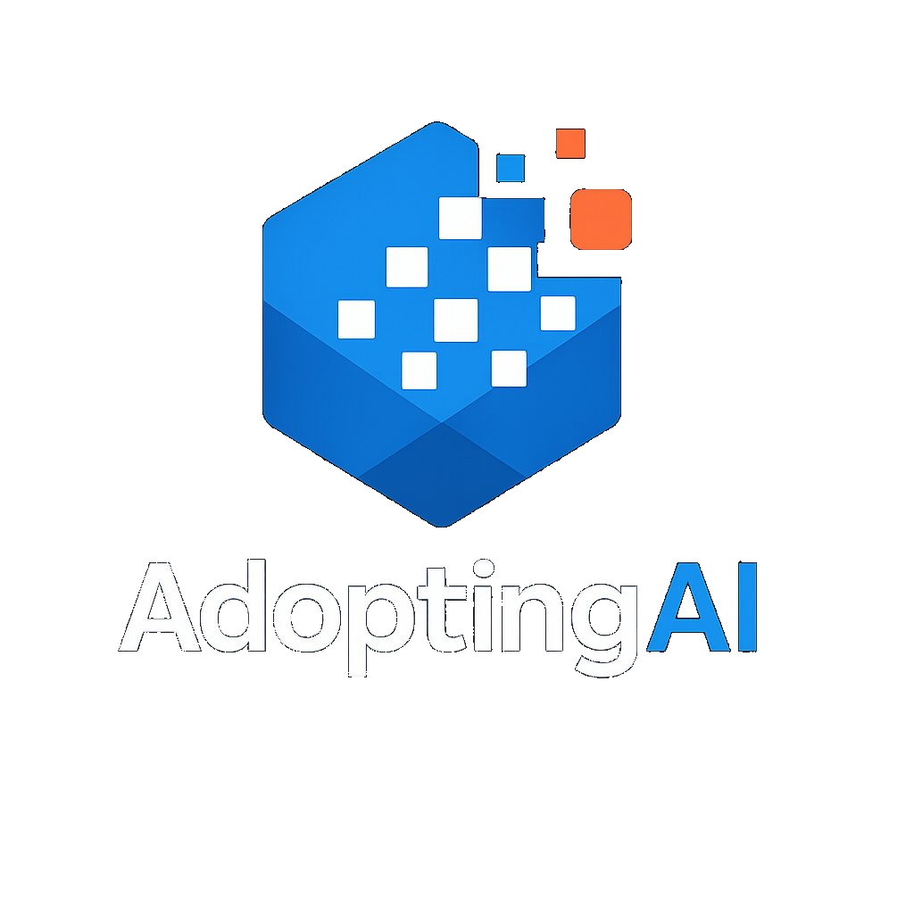 | ARIA  AI Readiness and Integration Advisory Framework  Methodology Overview | AdoptingAI

The Challenge
Most organizations struggle to identify where AI can genuinely transform their operations, not because AI capability is lacking, but because the opportunity is invisible from the inside. Business teams know their processes deeply but rarely have the frame of reference to see where AI could eliminate days of manual work, remove entire categories of decision bottlenecks, or replace months-long cycles with near-instant outputs. Teaching people what AI is and making technology options available does not solve this. Without a structured method for examining how work actually gets done, most organizations default to incremental thinking and miss the transformational opportunities entirely.

What is ARIA
ARIA is the AdoptingAI AI Readiness and Integration Advisory Framework. It is a structured engagement methodology that uses AI-powered research and specialized advisory expertise to surface where AI can create transformational operational value. ARIA produces a prioritized, evidence-based AI Strategy Roadmap: a detailed, client-specific proposal covering high-impact use cases, a readiness assessment, and a sequenced implementation plan grounded in the client's actual environment.
The output identifies what AI-enabled transformation is achievable and what preparation is required to get there. How that transformation is executed, whether through internal teams, third-party vendors, or a combination, is determined by the client based on the findings.
ARIA replaces weeks of manual research and shallow discovery with a structured, AI-accelerated process. The ARIA Research Tool conducts deep preparatory research automatically before any client meeting takes place. Every client interaction is structured around four operational lenses that surface AI opportunities the client may not have thought to ask for. And every output is produced through a combination of ARIA tooling and advisor expertise, making the engagement faster, deeper, and more defensible than traditional approaches.

The ARIA Process
ARIA moves through five stages, alternating between advisor-led analysis and structured client meetings. The visual below shows the full process at a glance.

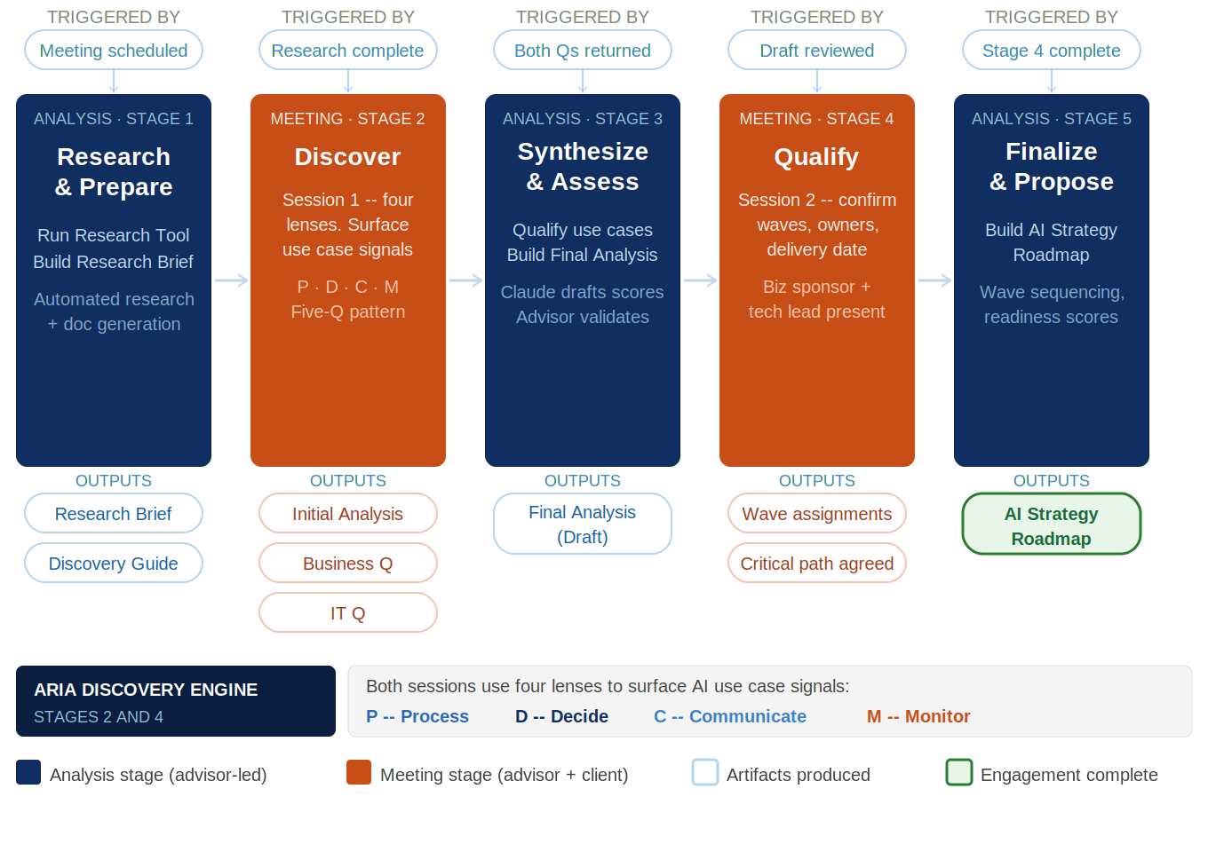

How ARIA Works
ARIA alternates between advisor-led analysis stages and structured client meetings. Analysis stages are where research is conducted, discovery is synthesized, and the final roadmap is produced. Meeting stages are where the advisor works directly with the client to surface opportunities and validate findings. Every client interaction is informed by deep preparation, and every piece of analysis is grounded in what the client actually said, not what research alone suggested.
Because the analysis stages are powered by ARIA AI tooling rather than manual research, the full engagement can move at a pace that traditional approaches cannot match. Both client meetings and all analysis between them can be completed within consecutive days. An engagement that would take weeks with conventional research and discovery can be delivered in a fraction of the time without sacrificing depth or defensibility.
Discovery is organized around four operational lenses: Process, Decide, Communicate, and Monitor. These lenses are explained in detail later in this document. Together they ensure that AI opportunities are surfaced systematically across the full operational landscape, including areas the client would not have identified through traditional intake or requirements processes.

Stage 1 -- Research and Prepare
The ARIA Research Tool conducts structured, AI-powered research on the client before any meeting takes place. It surfaces company context, technology environment, strategic signals, and initial use case candidates. The advisor reviews and validates the output before the meeting. This stage produces two documents: the ARIA Research Brief (advisor reads before the meeting) and the ARIA Discovery Guide (advisor uses as a working document during the session).
Stage 2 -- Discover
The first structured client meeting. The advisor uses the ARIA Discovery Guide to structure the conversation across four operational lenses. After the session, the advisor uses the ARIA Stage 2 tool to upload the completed Discovery Guide and session transcript. Claude produces three documents: the ARIA Initial Discovery Analysis, the Business Readiness Questionnaire, and the IT Readiness Questionnaire. Both questionnaires are sent to the client within 24 hours.
Stage 3 -- Synthesize and Assess
After both questionnaires are returned, the advisor pastes all inputs into the ARIA Stage 3 prompt and runs it in the ARIA Engagement Project. Claude applies the use case qualification gates, runs a completeness check against the relevant industry AI landscape, and drafts readiness scores from the questionnaire responses. The output is the ARIA Final Discovery Analysis (Draft) -- the first client-facing document. The advisor validates all qualification decisions and readiness scores before sending to the client.
Stage 4 -- Qualify
The second structured client meeting. With the readiness questionnaire completed and the Final Discovery Analysis in hand, the advisor and client work through each candidate use case to assess which are achievable given the client's actual environment. This session produces the validated, qualified use case set that the AI Strategy Roadmap will be built around.
Stage 5 -- Finalize and Propose
The advisor synthesizes all discovery and qualification inputs into the AI Strategy Roadmap. Readiness scores are applied across the four pillars. Use cases are prioritized and sequenced using three weighted dimensions: technical readiness, business urgency, and relative ROI. ROI is expressed as two advisor-derived inputs per use case: a Value size (High, Medium, or Low) provided by the client in the Stage 3 questionnaire, and an Investment size (High, Medium, or Low) derived by the advisor from the technical readiness findings, data infrastructure gaps, integration complexity, and implementation dependencies gathered across the engagement. High Value and Low Investment use cases are lead prioritization candidates. No single dimension wins automatically, but all dimensions are visible in the roadmap with sequencing rationale per use case. Preparation workstreams are identified. The roadmap is produced through ARIA AI tooling and advisor expertise and delivered as a detailed, evidence-based proposal the client can act on immediately.

Stage Summary

# | Type | Stage | Input | Output
1 | Analysis | Research and Prepare | Initial client meeting scheduled | ARIA Research Brief, ARIA Discovery Guide
2 | Meeting | Discover | ARIA Discovery Guide completed, transcript available | ARIA Initial Discovery Analysis, Business Readiness Questionnaire, IT Readiness Questionnaire
3 | Analysis | Synthesize and Assess | Both questionnaires returned by client | ARIA Final Discovery Analysis (Draft)
4 | Meeting | Qualify | ARIA Final Discovery Analysis (Draft) reviewed by client | Qualified use case candidates, Validated readiness inputs
5 | Analysis | Finalize and Propose | All discovery inputs gathered | AI Strategy Roadmap

ARIA Artifacts
Every ARIA engagement produces a standard set of artifacts. Each is produced through a combination of ARIA AI tooling and advisor expertise, with AI handling research generation and document assembly and the advisor providing validation, interpretation, and strategic judgment.

Artifact | Produced In | Purpose and Use
ARIA Research Brief | Stage 1 | Generated by the ARIA Research Tool using AI. Covers company background, technology environment, regulatory context, and strategic signals. Validated by the AdoptingAI advisor before the first client meeting. Not shared with the client.
ARIA Discovery Guide | Stage 1 | Pre-populated from research with anchor questions and blank capture fields. Advisor uses this as a working document during the session, filling in notes. Completed version plus transcript are the primary inputs to Stage 2.
ARIA Initial Discovery Analysis | Stage 2 | Produced after the session from the completed Discovery Guide and transcript. Five sections including Advisory Analysis. Internal only. Primary input to Stage 3.
Business Readiness Questionnaire + IT Readiness Questionnaire | Stage 2 | Generated automatically from session findings. Business questionnaire sent to business and operations leadership. IT questionnaire sent to technology leadership. Both sent within 24 hours of the discovery session with a five business day return deadline.
ARIA Final Discovery Analysis (Draft) | Stage 3 | Seven sections covering engagement status, pain area analysis, use case wave assignments, readiness summary, and recommended Stage 4 agenda. Readiness scores drafted by Claude and validated by advisor. Sent to client at least 48 hours before Stage 4.
AI Strategy Roadmap | Stage 5 | The final ARIA output. Prioritized use cases with sequencing rationale showing Value (client-provided H/M/L), Investment (advisor-derived H/M/L), and technical readiness for each use case. Readiness assessment results, preparation workstreams, and a sequenced implementation roadmap. Produced through ARIA AI tooling and advisor expertise.

Four Operational Lenses
The four operational lenses structure every ARIA discovery conversation. They ensure that AI opportunities are explored systematically across the full operational landscape, including areas the client would not typically identify through traditional intake processes. Each lens is applied with human judgment throughout, and human oversight is incorporated where the nature of the decisions or communications requires it.

P | Process | Examines how work gets done and where AI can enable intelligent, semantic workflow automation that goes beyond traditional rule-based approaches to handle complexity, variation, and judgment within operational tasks.  Intelligent document handling, semantic data extraction, adaptive workflow routing, and throughput improvement. Examples: intake processing, document generation, extraction from unstructured sources.
D | Decide | Examines where judgments or determinations are being made and where AI, with human oversight where appropriate, can improve the quality, consistency, and speed of those decisions.  Decision support, criteria application, scoring, and anomaly detection. Examples: clinical criteria application, risk stratification, claims anomaly flagging.
C | Communicate | Examines how information flows to and from stakeholders and where AI can improve the quality, speed, or personalization of those interactions, with human review applied where the stakes require it.  Response generation, content personalization, summarization, and AI-assisted messaging. Examples: member-facing chatbots, provider communications, internal briefings.
M | Monitor | Examines what the organization needs to track on an ongoing basis and where AI can surface signals, anomalies, or performance gaps that would otherwise require manual surveillance.  Surveillance, performance tracking, anomaly detection, and operational dashboards. Examples: quality measure gap monitoring, network adequacy, fraud pattern detection.

Note: This Claude-based version is the current implementation. A website-based version is planned. A new Playbook version will be issued when the website is available.

Example questions an advisor might ask during a live engagement: "I just finished my discovery session -- what do I do next?" -- "My client only returned one questionnaire -- should I wait or proceed?" -- "The IT team scored data readiness very low -- what does that mean for my Wave 1 candidates?" -- "My Stage 4 session is tomorrow -- what should I be prepared to confirm?" -- "Can you help me draft the cover email for the questionnaires?"

1. Document generation -- paste a stage prompt and Claude produces all branded Word documents for that stage automatically.

The project has two functions:

The ARIA Engagement Project is a dedicated Claude project that serves as the delivery platform for all ARIA engagements. It contains all prompt templates, document build specifications, brand assets, and the ARIA Framework Ground Truth as project knowledge. Any advisor can use it to run a complete ARIA engagement without prior context.

The ARIA Engagement Project

Key Principles
- Stage 1 use case candidates are research-informed starting points based on publicly available information. They give the first meeting a structured foundation and will be refined significantly through actual discovery.
- The Business and IT Readiness Questionnaires are generated automatically at the end of Stage 2 from the session findings. Questions are tailored to the specific use case candidates identified in the discovery meeting -- not sent as a generic template.
- Readiness scoring is drafted by Claude in Stage 3 from the questionnaire responses. The advisor validates all scores using the AI Readiness Scoring Template before the ARIA Final Discovery Analysis is sent to the client.

On the AI Strategy Roadmap: the advisor must stand behind every recommendation as their own professional judgment. Preparation workstreams, sequencing rationale, and next steps must reflect the advisor's expertise in regulated industry AI adoption -- not just what the questionnaire responses and scoring algorithm produced. This is the document the client will use to make investment decisions.

On the ARIA Final Discovery Analysis (Draft): the advisor must validate all readiness scores against their knowledge of the client's industry and infrastructure environment, confirm that wave assignments reflect genuine feasibility and not just questionnaire responses, and adjust pain area narratives to reflect what was actually heard in the session. Claude drafts -- the advisor judges.

Level 2 -- Expert validation and substantive input required: Claude produces a structured draft, but the advisor's domain expertise is essential to validate the analysis, adjust findings, and make professional judgments that AI cannot make. The document is not ready to send until the advisor has worked through it substantively. Applies to: ARIA Final Discovery Analysis (Draft) and AI Strategy Roadmap.

Level 1 -- Review and adjust: The advisor reviews the AI-generated output, corrects any errors, adjusts questions or framing as needed, and then sends or uses the document. Applies to: ARIA Research Brief, ARIA Discovery Guide, ARIA Initial Discovery Analysis, Business Readiness Questionnaire, IT Readiness Questionnaire.

Two levels of human involvement apply across the engagement:

Every AI-generated document requires advisor review before it reaches the client or is used as input to the next stage. ARIA tooling produces the starting point. The advisor owns the output.

- ARIA AI tooling handles research generation and document assembly. The AdoptingAI advisor provides validation, strategic interpretation, client context, and domain expertise. Both are required to produce a defensible output.
- The four operational lenses persist across the full engagement, from research framing in Stage 1 through use case categorization in the final roadmap.
- The full ARIA engagement, including both client meetings and all analysis, can be completed within consecutive days due to the AI-powered nature of the research and synthesis stages.
- Use case prioritization draws on three weighted dimensions: technical readiness, business urgency, and relative ROI. ROI is expressed as Value (High, Medium, or Low, provided by the client in the Stage 3 questionnaire) and Investment (High, Medium, or Low, derived by the advisor in Stage 5 from technical and infrastructure findings). High Value combined with Low Investment identifies lead candidates. No single dimension automatically determines sequence, but all dimensions are visible in the roadmap with rationale per use case.

